Site plan example:

The site plan should be saved as a .doc or .pdf and show the property perimeter, the site of the electricity meter and also include an aerial image of the property as per the below two images:

https://pastmap.org.uk/map - can be used to draw polygons around property boundaries

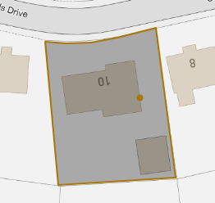

The best mapping tool for high resolution imagery in Orkney is Bing maps

